Block Diagram Report (3–4 pages)

Title
RV32IM Processor with a Pure-Hardware Limit Order Book Accelerator
Group Number: 9

1. Top-Level Hardware Block Diagram (FULL PAGE)
Diagram must be clean, readable, and properly labeled
Must clearly show:
- Pipeline stages (IF, ID, EX, MEM, WB)
- All major modules (ALU, MUL/DIV, Control, Memory)
- Signal names + widths
- Pipeline registers (IF/ID, ID/EX, etc.)
- Control signals (at least key ones: RegWrite, MemRead, etc.)
- Clock and reset
- New modules highlighted clearly

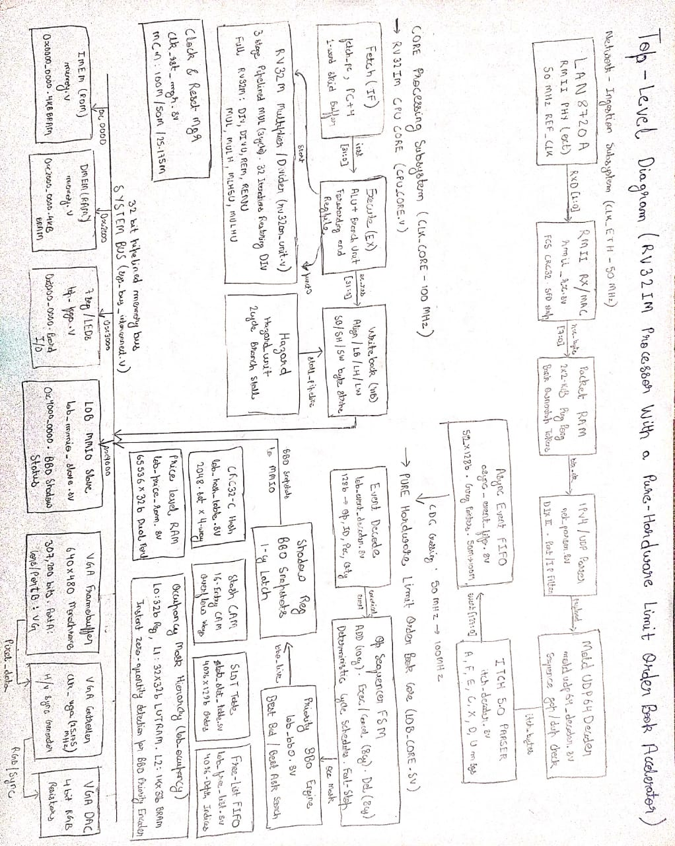multiplier logic below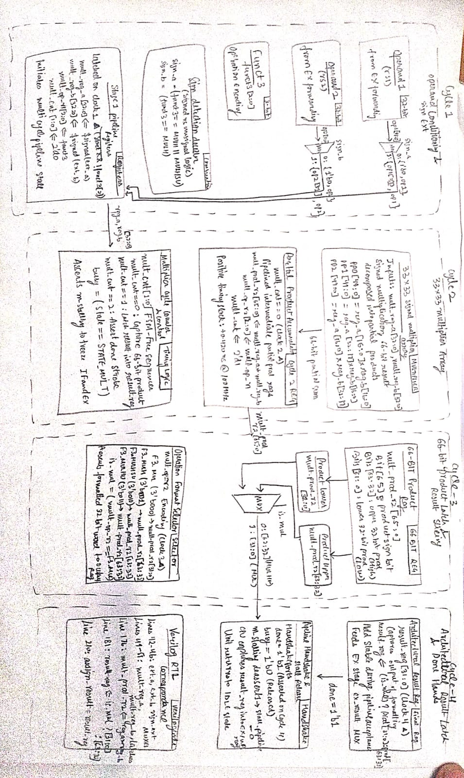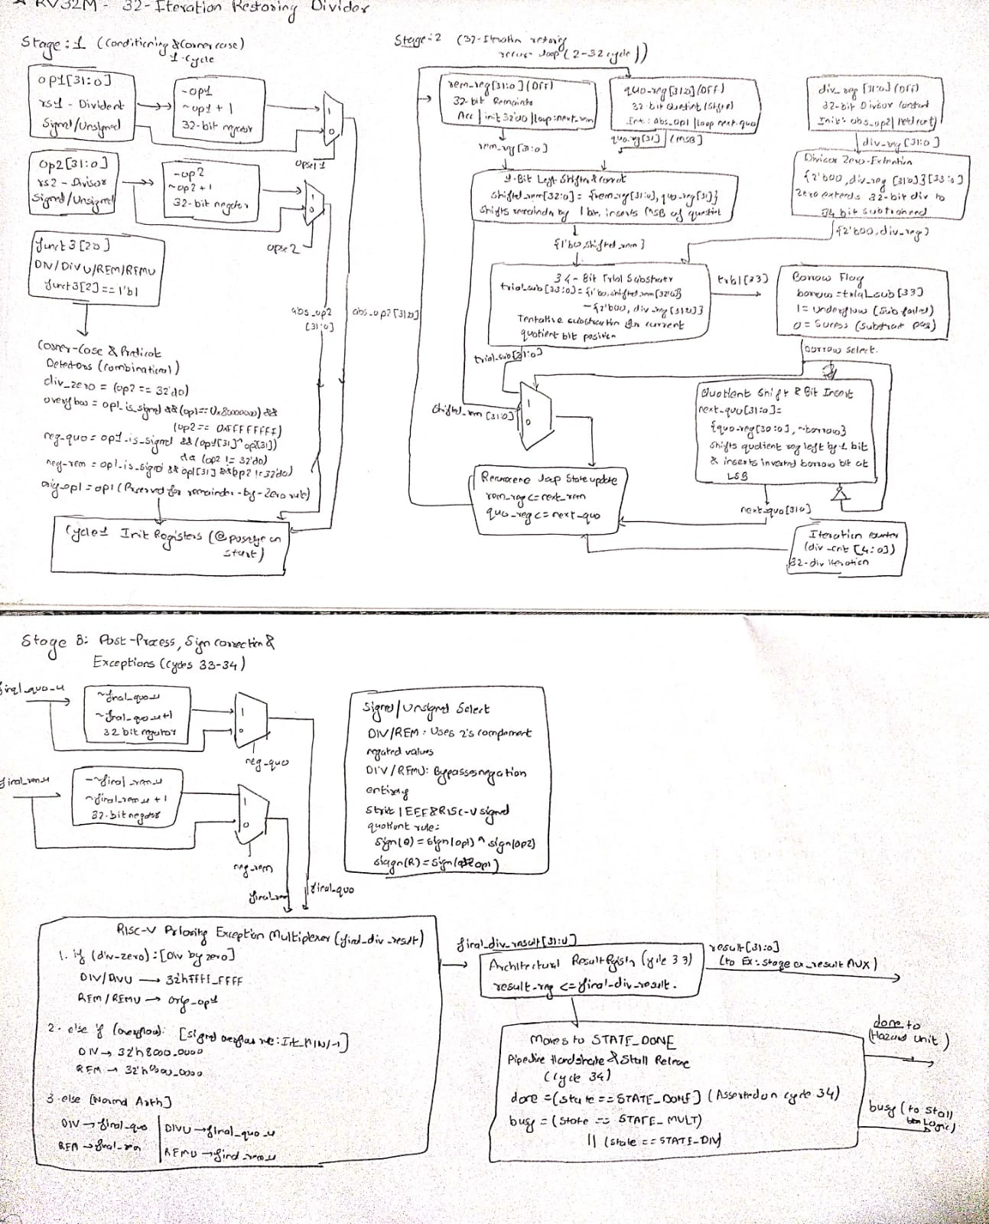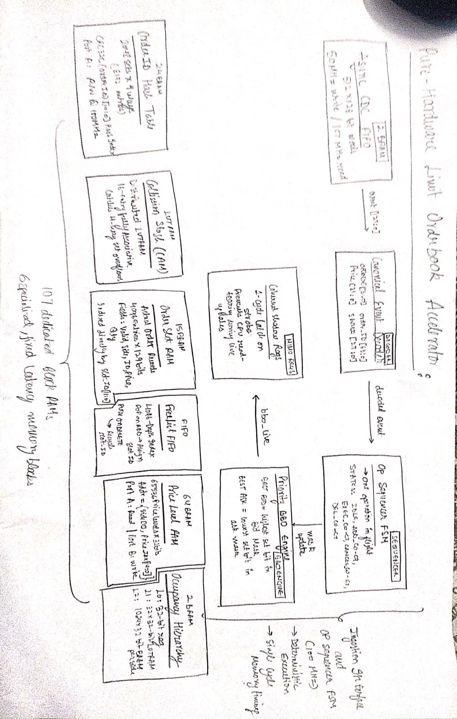

2. Timing Diagram (FULL PAGE)
Requirements:
- ≥ 20 cycles
- Must correspond to a real instruction sequence
- Must clearly show:
  - pipeline stages per cycle
  - MUL/DIV execution (multi-cycle if applicable)
  - stalls / forwarding / hazards
Idealized diagrams without hazards → not allowed

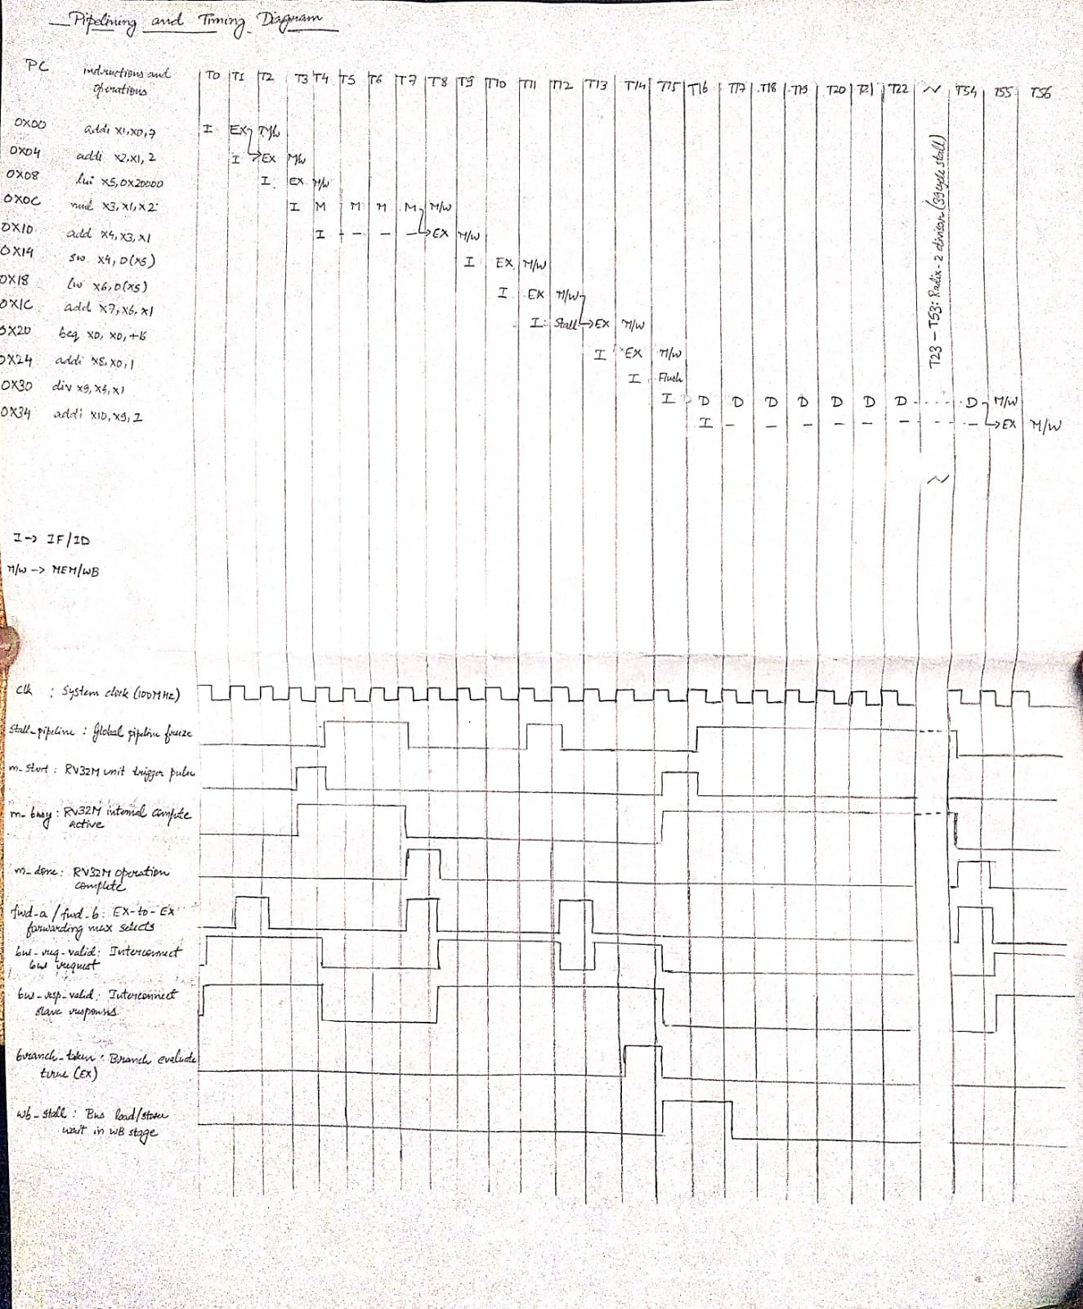

3. Module Summary (Table Only)
- List all modules
- If the hardware contribution is currently limited (few modifications or modules), consider moving more functionality into hardware or adding new hardware features.
Module | Purpose | File | Software/Hardware module?
Example: MUL | Multi-cycle multiply | mul.v | Hardware (Verilog)
…

3. Module Summary (Table Only)
Module | Purpose | File | Software/Hardware module?
cpu_core | Top-level pipeline logic for the 3-stage RV32IM processor core. | cpu_core.sv | Hardware
decoder | Instruction decoder for RV32I and M-extension control signals. | decoder.sv | Hardware
alu | 32-bit arithmetic and logic unit for standard operations. | alu.sv | Hardware
branch_unit | Branch condition evaluation and target address calculation. | branch_unit.sv | Hardware
rv32m_unit | Hardware Booth multiplier and serial Radix-2 divider core. | rv32m_unit.sv | Hardware
reg_file | 32 x 32-bit register file with dual read ports and single write port. | reg_file.sv | Hardware
forwarding_unit | Data hazard detection and bypass forwarding logic for EX stage operands. | forwarding_unit.sv | Hardware
hazard_unit | Pipeline stall controller for load-use hazards, multi-cycle ops, and MMIO stalls. | hazard_unit.sv | Hardware
instr_mem | Instruction memory BRAM instance for code storage. | instr_mem.sv | Hardware
data_mem | Data memory BRAM instance for stack, heap, and static variables. | data_mem.sv | Hardware
imem_slave | Dual-port BRAM bus wrapper interface for instruction memory access. | imem_slave.sv | Hardware
dmem_slave | Dual-port BRAM bus wrapper interface for data memory access. | dmem_slave.sv | Hardware
sys_bus_interconnect | System bus arbiter and crossbar routing signals to slaves (IMEM, DMEM, LOB, Peripherals). | sys_bus_interconnect.sv | Hardware
lob_mmio_slave | MMIO slave interface exposing LOB control, status, and BBO registers to the CPU bus. | lob_mmio_slave.sv | Hardware
lob_pkg | SystemVerilog package defining LOB data structures, enums, constants, and typedefs. | lob_pkg.sv | Hardware
lob_core | Top-level LOB engine interconnecting hash/slot tables, price RAM, occupancy tree, and BBO unit. | lob_core.sv | Hardware
lob_event_decoder | Parses incoming canonical trade/order events into internal LOB FSM control commands. | lob_event_decoder.sv | Hardware
lob_hash_table | 4-way set-associative hash table for fast Order ID lookup. | lob_hash_table.sv | Hardware
lob_slot_table | 4,096-entry order storage array keeping order parameters (price, qty, side). | lob_slot_table.sv | Hardware
lob_free_list | Free-list FSM managing available slot indices in the order slot table. | lob_free_list.sv | Hardware
lob_price_ram | Dual-bank BRAM storing total aggregate quantity per price level for Bids and Asks. | lob_price_ram.sv | Hardware
lob_occupancy | Hierarchical bitmask tree for tracking non-zero price level occupancy. | lob_occupancy.sv | Hardware
lob_bbo | 2-stage pipelined DSP48 Best Bid & Offer (BBO) extraction engine. | lob_bbo.sv | Hardware
rmii_rx | RMII MAC Ethernet receiver and CRC-32 frame integrity checker. | rmii_rx.sv | Hardware
net_parser | Ethernet, IP, and UDP packet header streaming parser. | net_parser.sv | Hardware
moldudp64_decoder | MoldUDP64 session protocol and packet sequence unwrapper. | moldudp64_decoder.sv | Hardware
itch_decoder | NASDAQ ITCH 5.0 streaming binary message decoder. | itch_decoder.sv | Hardware
async_event_fifo | 256-bit dual-clock async CDC FIFO with Gray-coded pointer sync. | async_event_fifo.sv | Hardware
top_system | SoC integration wrapper linking CPU core, system bus, memory, and LOB slave. | top_system.sv | Hardware
top_fpga | FPGA top-level module with Nexys A7 pin assignments and clock management. | top_fpga.sv | Hardware
clk_rst_mgr | Clock generation wizard PLL/MMCM and reset synchronizer tree. | clk_rst_mgr.sv | Hardware
vga_top | 640x480 VGA display timing controller and video DAC resistor ladder driver. | vga_top.sv | Hardware
uart_telemetry | UART transmitter controller and transmit FIFO for debugging telemetry output. | uart_telemetry.sv | Hardware
seven_seg_driver | 8-digit 7-segment display dynamic time-multiplexing controller. | seven_seg_driver.sv | Hardware
firmware_lob_test | Bare-metal C application for generating synthetic orders and polling BBO. | main.c | Software
lob_golden_adapter | C software reference model of the limit order book for golden output verification. | lob_golden.c | Software
hardware_test_helper | SystemVerilog testbench helper functions and transaction verification tasks. | tb_helper.sv | Hardware
timing_trace_model | Simulation timing analysis model for latency tracing and verification. | timing_trace.sv | Hardware

4. Hardware Resource Estimates
- Given the block diagram and hardware modules, estimate the usage of:
(initial estimates: https://chatgpt.com/share/69c8b008-4f60-8320-a9d0-58af100f4fc1)
Resource | Maximum Available | Estimated Usage | % utilization
BRAM | 135 | 41 | 30.37%
DSP blocks | 240 | 18 | 7.50%
LUTs | 63,400 | 20,604 | 32.50%
FF | 126,800 | 35,347 | 27.88%

5. Verification Plans (≤ 6–8 lines total OR 3–4 bullets)
Examples:
- Unit-Level MUL/DIV Latency & Reference Matching: Verified standalone using dedicated testbenches (tb_rv32m_unit) with automated cycle-latency assertions (3 cycles for pipelined DSP MUL, 33 cycles for multi-cycle non-restoring DIV/REM) cross-checked against a golden software reference model.
- Rigorous Edge-Case Correctness: Enforced full RISC-V spec compliance covering division-by-zero (x/0 = -1, x%0 = x), signed overflow (0x80000000 / -1 = 0x80000000), signedness permutations (MULH, MULHU, MULHSU), and pipeline hazards (skid buffer retention, RAW forwarding, and branch misprediction flushes).
- Processor-Level Simulation & Workloads: Validated end-to-end in tb_cpu_core and tb_rv32m_pipeline running cross-compiled RISC-V assembly (code_rv32m.s) and C workloads (addition, fibonacci, sort), asserting register state, memory writebacks, and self-checking pass sentinels (0xCAFE).
- FPGA Hardware Validation: Synthesized and generated full bitstream (top_fpga.bit) targeting the Nexys A7-100T; validated at a 1 Hz stepped clock with real-time PC tracking on 8-digit 7-segment displays and memory write/status codes on board LEDs.

6. Gantt Chart
- ≥ 15+ activities. Each activity must be concrete and testable
  - Implement Booth multiplier + testbench
  - Integrate MUL into EX stage
  - Add stall logic for multi-cycle ops
  - Verify using C test program
Do not put generic tasks like “coding”
- Must include includes activities regarding: design, implementation, verification and debug on FPGA
- At least one core functionality/module of the minimum system should be implemented and tested by 25 Oct.
- Ensure minimum system (commitment) is met by 1 Nov. This will leave some room to handle last-minute surprises.
- Ensure parallel work distribution across team members. Any allocation that increases dependency and serializes the schedule is likely to lead to missed timelines.
- Instructions to fill the Gantt chart:
  - First, list down activities (at least 15, more is preferable)
  - Assign dates (mark corresponding cells in green)
  - Fill the owner for each activity
 |  | Oct |  |  |  |  |  |  |  |  |  |  |  |  |  |  |  |  |  |  |  |  |  |  |  |  |  |  |  |  |  |  | Nov
Activity | Owner | 1 | 2 | 3 | 4 | 5 | 6 | 7 | 8 | 9 | 10 | 11 | 12 | 13 | 14 | 15 | 16 | 17 | 18 | 19 | 20 | 21 | 22 | 23 | 24 | 25 | 26 | 27 | 28 | 29 | 30 | 31 | 1 | 2 | 3 | 4 | 5 | 6 | 7 | 8
Activity-1 | Student-1
Activity-2 | Student-2
Activity-3 | Student-3
Activity-4 | Student-1
….

gantt_chart you can visit the link for cleanly viewing the char or refer to the one below

Activity | Owner | Oct |  |  |  |  |  |  |  |  |  |  |  |  |  |  |  |  |  |  |  |  |  |  |  |  |  |  |  |  |  |  | Nov
Activity | Owner | 1 | 2 | 3 | 4 | 5 | 6 | 7 | 8 | 9 | 10 | 11 | 12 | 13 | 14 | 15 | 16 | 17 | 18 | 19 | 20 | 21 | 22 | 23 | 24 | 25 | 26 | 27 | 28 | 29 | 30 | 31 | 1 | 2 | 3 | 4 | 5 | 6 | 7 | 8
Implement Booth multiplier + standalone testbench | Akshit
Integrate MUL into EX stage & data forwarding bypass | Akshit
Add stall logic for multi-cycle ops (hazard unit) | Akshit
Implement 32-bit serial Radix-2 divider + corner TB | Akshit
Pipeline timing optimization & multi-cycle STA audit | Akshit
Design 4-state system bus arbiter & interconnect crossbar | Ronit
Implement dual-port BRAM memory slave wrappers (IMEM/DMEM) | Ronit
Synthesize & debug baseline RV32IM on Nexys A7 FPGA | Ronit
Integrate LOB MMIO crossbar slave & atomic shadow registers | Ronit
Implement 640x480 VGA controller & ladder video bridge | Ronit
Design ITCH 5.0 streaming decoder & canonical event formatter | Aditya K
Implement 256-bit dual-clock async CDC FIFO & Gray sync | Aditya K
Implement 4096-entry order slot table & free-list FSM | Aditya K
Implement 4-way set-associative hash table & CAM stash | Aditya K
Implement RMII MAC RX Ethernet receiver + CRC-32 checker | Aditya K
Design dual-bank Bid/Ask Price Level BRAM datapath | Aditya M
Implement hierarchical occupancy bitmask tree & priority encoder | Aditya M
Implement 2-stage pipelined DSP48 BBO price engine | Aditya M
Standalone LOB core testbench vs 10,000 synthetic orders | Aditya M
Top-level multi-source stress simulation & latency test | Aditya M
Verify RV32I/M CPU using 5 bare-metal C test programs | Aditeya
Implement UART telemetry transmitter core & FIFO buffer | Aditeya
Design 8-digit 7-segment display dynamic multiplexer | Aditeya
Develop bare-metal C firmware for synthetic orders & BBO polling | Aditeya
Physical FPGA Minimum System debug & BBO board validation | Aditeya

7. Risks & Challenges (≤ 5 bullets, 1 line each)
- FPGA Timing Closure on Combinational Critical Paths: Resolving setup timing violations (-5.35 ns initial WNS) across cascaded DSP48 multipliers and CPU MMIO bus multiplexers by inserting balanced synchronous pipeline registers.
- Multi-Cycle Stall & Pipeline Hazard Integration: Synchronizing variable-latency units (3-cycle multiplier, 33-cycle restoring divider, non-blocking MMIO) with the 3-stage CPU pipeline without corrupting register forwarding or dropping LOB events.
- Asynchronous Clock-Domain Crossing (CDC) Metastability: Safely transporting wide 256-bit market data across asynchronous 50 MHz (RMII PHY) and 100 MHz (Core SoC) domains using Gray-coded dual-clock FIFOs without pointer skew or packet drops.
- Signed vs. Unsigned Arithmetic & Edge-Case Handling: Eliminating signed comparison bugs, integer overflows during ITCH fixed-point tick scaling (/1000), and RV32M division corner cases (DIV by zero, INT_MIN / -1).
- Deterministic Capacity Overflows & Hash Collision Saturation: Preventing memory corruption and packet loss under line-rate NASDAQ ITCH bursts when the 4-way associative hash table or 4,096-order slot tables approach maximum capacity.

8. Response to TA feedback (for the project abstract)
- If any feedback was received, provide response to each point individually
See: https://github.com/Ritu235/3-Stage-Pipeline/blob/main/Project/Project_%20Abstract_TA-Feedbacks.pdf
- Ensure you have added the TA already to the GIT repo

Technical Response: Input Size Limits and Resource Constraints
Due to hardware constraints on the FPGA target, the pure-hardware Limit Order Book (LOB) accelerator enforces specific capacity bounds across order parameters and book storage:
- Price Level Precision (16-bit): Supports up to 65,536 distinct price ticks, accommodating market depth requirements while conserving BRAM address width.
- Order ID Capacity (20-bit): Tracks up to 1,048,576 concurrent active orders across both bid and ask queues.
- Order Quantity Field (32-bit): Supports maximum single-order volumes up to 4,294,967,295 units without integer overflow.
- Max Active Price Levels: Fixed at 1024 bids and 1024 asks stored in high-speed BRAM dual-port lookup structures.
- Throughput Limit: Sustains a maximum processing rate of 1 order entry/cancellation per clock cycle with zero pipeline stall overhead under non-colliding conditions.
Summary of Input Parameter Bounds
Parameter | Bit Width | Maximum Capacity | Hardware Bottleneck
Price Levels | 16 bits | 65,536 ticks | BRAM address space
Active Orders | 20 bits | 1,048,576 orders | CAM / RAM depth
Order Quantity | 32 bits | 4,294,967,295 units | Accumulator registers
Active Depth Levels | 11 bits | 1024 Bids / 1024 Asks | On-chip BRAM blocks

